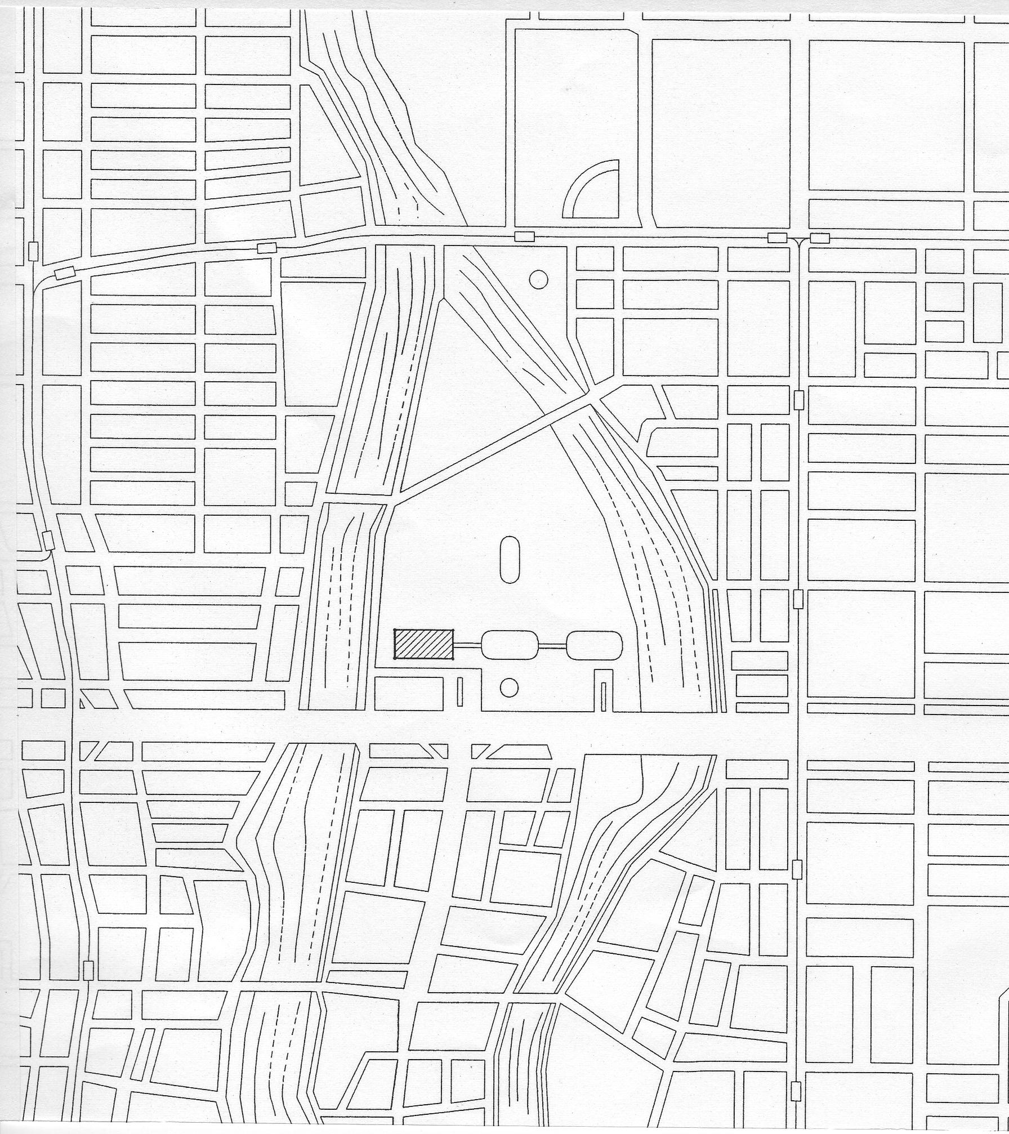
Park

Honkawa Elementary School ●

● Fountain
Funairi-machi

Heiwa Ohashi Bridge

Hiroshima Prefectural Sports Center
●
Hiroshima
Museum
of Art ●
- Areas marked by dotted lines are business districts and there are many eating places.
- Many other restaurants in and around Shareo (Underground Shopping Plaza), Sogo Dept. Store, Bus Center, Pacela and Rihga Royal Hotel.
↑to Hiroshima Castle
to Hiroshima → Station

Rihga Royal ●
Hotel
- Hiroshima
Prefectural Office

Pacela ●
Hiroshima Municipal Baseball Stadium●
Hiroshima Chambers of Commerce & Industry ●

Mielparque
Hiroshima
●

● Sogo Dept Store
● Bus Center

to
Hiroshima → Station
Honkawa-cho
Tokaichi-
machi
A-bomb Dome
Aioibashi
Bridge

● entrance to Shareo
Kamiya-cho
higashi
Kamiya-cho
nishi

●
A-bomb dome

Prefectuｒal Culture
Center
●

●Deodeo

● Hiroshima Bank

Motoyasubashi
Bridge
Children’s
Pease Monument ●
Hondori Shopping Area

Hondori

River Cruise Boarding Pontoon
⑱

Peace Memorial Park
●
Tourist Information
& Souvenir Shop

⑰
Honkawa-cho
Bridge

●Fukuro-machi Elementary School
●Hotel Park Side

Dobashi

Hotel Hokke
Club ●
Cenotaph for A-bomb victims ●

Motoyasu-
gawa River
⑯
Fukuro-machi

Int’l Conference Center Hiroshima
●

Hiroshima Peace Memorial Museum
●
⑬⑭⑮

●Hiroshima
Television
●ＮＨＫ

Chugoku
Shinbum ●
● ANA Hotel

Heiwa Odori Ave.
Nishi Heiwa
Ohashi Bridge
①②
⑫
The Gates of Peace
●
Heiwa Odori Ave

④

● ●Hotel Dormy-inn
Comfort Hotel
Hotel Sunroute Hiroshima
●⑲
③
⑤⑥ ⑦
⑧
⑳
●Chugoku
Denryoku Ltd.
Chuden-mae
⑨

Kosei Nenkin Kaikan ⑩
●

Nakajima-kanzaki-
bashi Bridge
●Chuo Post office
Aster ●
Plaza ⑪

Shin-meiji-bashi
Bridge

●Naka Ward Office

Shiyakusho-
mae
●Hiroshima City Hall
0ｍ 100ｍ 200ｍ

↓To Hiroshima Port
(Ujina)
International Conference Center: restaurant SERENADE (B2 floor, 100 seats)

① RISTORANTE MARIO (Italian, 42 seats)
② Restaurant SUNSHINE
③ HIROSHIMA (Oyster boat)
④ KANAWA (Oyster boat)
⑤ Ramen (Chinese noodles)
⑥ Udon noodles
⑦ SEVEN－ELEVEN (convenience store)
⑧ 2 light-meal-restaurants
⑨ KAKOTEI (Chinese and set meals)
⑩ Hiroshima Kosei Nenkin Kaikan: Restaurant FOUR SEASONS (1st floor, 100 seats),
Restaurant SUBARU (3rd floor, 30 seats)
⑪ Aster Plaza: Restaurant YOSHOKU KOBO (1st floor, 80 seats)
⑫ Light meals
⑬ KARI (Chinese)
⑭ OKONOMIYA (okonomiyaki)
⑮ WATANABE (Japanese)
⑯ NOBUMOTO (okonomiyaki)
⑰ SEVEN－ELEVEN (convenience store)
⑱ ICHIRYU (Chinese)
⑲ Hotel Sunroute: Japanese and Italian restaurants on 15th floor
⑳ SEGAWA (Japanese), YAOKI (ramen), Spanish restaurant, YUMEYA (Japanese),
SAKAE (udon), HANA-CHAN (okonomiyaki), TANUKI (udon)
Japanese, Ramen
LAWSON (convenience store)
SEVEN－ELEVEN (convenience store)
ANA Hotel (Chinese, Japanese, Italian and Teppanyaki restaurants)
SAGA (light meals)
SEVEN－ELEVEN (convenience store)
SANPEI (Japanese), FUJIWARA (Japanese)
2 Japanese restaurants
Shokking city restaurant mall: okonomiyaki, yakiniku, Japanese, Sushi
Prefectural Culture Center: RIJOY (café-restaurant, 1st floor, 68 seats),
ABI (Japanese, B1 floor, 79 seats), MAPLE (cafeteria, 32 seats)

